**Action Research**

**The impact of a Tech-Infused Problem-Based Learning Project on Student Motivation & Attitude Towards Science**

*“Telling children how scientists do science does not necessarily lead to far-reaching changes in how children do science; indeed, it cannot, as along as the school curriculum is based on verbally expressed formal knowledge”. (Papert, 1991, pp. 10 ± 11)*

**Abstract:**

The purpose of this paper was to synthesize literature related to Problem-based learning (PBL) and the infusion of multimedia into a collaborative virtual environment, such as Blackboard, and to examine the effect of such pedagogies and tools on student motivation and interests.

Following this discussion, I further clarified and illuminated the value of these characteristics for the creation of a technology-infused PBL by using them as evaluative criteria for characterizing the Collaboratory in which the learners embark on a 12-week long journey. I also described how Blackboard may be leveraged to support the Collaboratory. Two high school classes were used in the study. T-tests were employed in the statistical analysis of data to investigate the impact of technology on science learning attitude and motivation. Limitations of the implementation of the Collaboratory in the classroom were also highlighted. Results supported the positive effects of this Tech-infused PBL environment on science motivation.

**Problem:**

The student enrollment in the Chemistry classes at my school is relatively low compared to other science classes. After conducting pre-survey tests, the results showed the low motivation/lack of interest in learning chemistry.

My central goal in this Action Research Project was to use advanced technologies (Blackboard[1] and Multimedia software programs) and approaches to pedagogy (social constructivism) to help make the teaching and learning of science in classrooms interesting, motivating and similar to the practice of science by professionals (Pea, 1993). I proposed to investigate the effects of a “Collaboratory”[2] on the HS Science students’ motivation and attitude.

* Plan: to use a virtual workplace in which students collaborate with their peers to create multimedia products.
* Technology used: Blackboard (e-learning/web-based project) and multimedia software programs (MM).
* Participants:

1. Students work on projects in teams using blackboard as a platform.
2. Teacher is a facilitator/provides guidance for inquiry.

* Pedagogies: Problem Based Learning (social constructivist & cooperative learning).
* Description of such learning environment: Collaboratory.

**Research Questions:**

The focus of this study was to explore the use of a commercially available Internet course management system, namely Blackboard, as a supplement to traditional classroom teaching and learning within a high school science context. My choice of topic for research arose from a belief that the use of such a course management system could prove helpful in bringing innovative communication tools and multimedia programs and addressing the pedagogical problems outlined above.

This educational action research study attempted to explore these and other issues in the context of a small-scale study. The main purpose of the study is to determine if the use of a course management system could enhance the motivation of high school students in the learning of science. The fundamental research question behind this study was how the implementation of a *Collaboratory*, used as a supplement to traditional science classroom teaching, impacts the motivation of students? As discussed above Blackboard will be used to support the *Collaboratory* environment and create an online community for the students.

How could this technology affect student motivation, attitude, and interest in learning science?

It also considered if the use of multimedia programs (Dreamweaver, PowerPoint, i-Movie) in the classroom helps students represent and develop solutions to local ecological problems.

It also investigated how these multimedia (MM) artifact production can influence the students’ attitudes to learning?

Moreover, it considered whether the use of a *Collaboratory* necessitated the application of alternative pedagogical approaches by the teacher. In other words, can socio-constructivist approaches accommodate these technologies or must alternative methods be applied? This suggestion was succinctly encapsulated in the following quotation, which also indicates recent trends in this area of educational research:

In a similar vein, this particular research attempted to investigate the potential of Blackboard to enhance the learning experience of high school students. It is not proposing that these students will learn more through using Blackboard than through traditional approaches. Rather it is exploring the possibility that virtual learning environments in conjunction with collaborative and problem-based learning can enhance the learning already taking place. It seeks to elicit the views of the students and perhaps go some way towards addressing all the issues outlined above.

In the study below, I used the word “Collaboratory” to describe the learning environment understudy.William Wulf was working for the U.S. National Science Foundation when he originally described a Collaboratory as a center without walls, in which the nation's researchers can perform their research without regard to geographical location--interacting with colleagues, accessing instrumentation, sharing data and computational resource[s], and accessing information in digital libraries. (Kouzes, Myers, & Wulf, 1996). Collaboration is also when students come together to share their expertise, to construct something more than they might have alone **(synergy),** and to learn from one another in the **process.** Virtual workspaces are being created. Their creation is transforming the way students learn, communicate, and work together with technology. The collective, virtual yet visible workspaces are called Collaboratories, a new word derived from collaboration and laboratory.

**Literature Review:**

This review is structured under four sub-headings, PBL, on-line course management systems, multimedia artifacts and pedagogical motivation.

Each of these headings relates directly to the study's theoretical and conceptual frameworks. It is primordial to note that each of the subheadings are interrelated and interdependent in terms of their relevance to the research questions and are merely subdivided for ease of orientation.

**PROBLEM-BASED LEARNING**

Problem-based learning (PBL) has many variations but all require a problem as the stimulus for learning, are an educational approach, not an isolated instructional technique, and are student-centered. Problem-based (PBL) learning has been extensively used in medical education with claims of providing numerous benefits for professional development and learning in a way that is especially relevant to future professional practice. Other disciplines such as business (Stinson & Milter, 1996), science (Arambula-Greenfield, 1996; Kingsland, 1996), mathematics (Seltzer, Hilbert, Maceli, Robinson, & Schwartz, 1996), architecture (Kingsland, 1996), biochemistry (Cohen, 1994), and computer science (McCracken & Waters, 1999) are using problem-based learning as an educational approach. Even though PBL is a well-defined instructional method, it has been characterized as an approach to learning rather than a teaching technique (Engle, 1997).

Description of Problem-Based Learning

PBL may have as many different descriptions as proponents. However, there are some common characteristics found in nearly all problem-based learning designs. Charlin, Mann, and Hansen (1998) proposed three core principles for distinguishing PBL and non-PBL educational activities. The first principle requires a problem as the stimulus for learning. Second, in agreement with Engle (1997), PBL is not an isolated instructional technique, but an educational approach. The third and final principle, defining PBL is that it is a student-centered approach. These principles are accompanied by four criteria concerning the effect on student learning. PBL (a) requires active processing of information, (b) activates prior knowledge, (c) provides a meaningful context, and (d) stimulates opportunities for elaboration and organization of knowledge.

Albanese and Mitchell (1993), in their seminal review of issues surrounding the controversy between traditional and PBL approaches to medical education, define it as "… an instructional method characterized by the use of patient problems as a context for students to learn problem-solving skills and acquire knowledge about the basic and clinical sciences" (p. 53). Problem-based learning is distinguished from other problem-centered methods such as the case method, in that the problem provides the motivation for learning the basic concepts (Berliner, 1998). The problem is presented *before* the learner is exposed to the subject or content knowledge. Learning proceeds from the "need to know" in order to solve the problem. Many of the benefits claimed for PBL are rooted in this concept. However, before discussing the benefits, a detailed description of a typical PBL process is appropriate.

The process begins when an authentic problem is presented to a small group of students. The group size is generally four to seven students; however, variations for large groups do exist (Rangachari, 1996; Woods, 1996). In addition to authentic, problems should be complex and ill-structured (Barrows, 1994; Koschmann, Kelson, Feltovich, & Barrows, 1996; Stepien & Pyke, 1997). Once students are presented with the problem, they follow an analysis process of determining what they, collectively, know about the problem and what they need to know to solve the problem. Students are then expected to individually use resources they discover for themselves, to acquire the knowledge required for solving the problem. The knowledge needs assessment, selection of resources, and knowledge acquisition is self-directed learning. The group reconvenes to share their individually acquired knowledge and continue the problem solving activity. This assesses—acquire—share cycle repeats until a satisfactory solution is achieved. A key element required for learning is a reflection activity that concludes the PBL process. This last stage consists of self and peer evaluation of abilities as problem-solvers, self-directed learners, and as members of the group (Barrows, 1994, pp. 70-6).

Effective problem-based learning methods do not rely on students to follow the process described above without direction and support. Tutors provide guidance and direction by working closely with each small group during the problem identification, learning issues definition, and reflection activities. An important characteristic of the tutor’s role is its emphasis on the processes rather than the subject matter content necessary to address the problem. The tutor’s primary role must be guiding students through the use of metacognitive skills needed for the problem at hand and for future practice. "This concept of metacognitive thinking skills provides the key to the positive, active role of the tutor" (Barrows, 1988, p. 3). Obviously, tutors must be skilled in both the PBL process as well as reasoning skills. An interesting debate centers on the question of whether tutors should or should not be subject matter experts.

Since the development of metacognitive skills is only one goal of PBL, a discussion of PBL’s many other benefits are appropriate. The following section briefly describes the more commonly cited advantages expected from using problem-based learning.

Benefits of Problem-Based Learning

The acquisition of subject matter knowledge must be an objective, without which, problem-based learning would have limited value. Much research has been done to show that this goal is satisfied, although, slightly less well than traditional learning methods (Albanese & Mitchell, 1993). Medical schools found that many students, taught with the traditional subject-based methods, were deficient at applying or transferring their knowledge to clinical problems (Barrows, 1994). Research shows that this deficit is largely solved by the acquisition of knowledge from within the context of actual practice, that is, with problem-based learning (Albanese & Mitchell, 1993; Hmelo, Gotterer, & Bransford, 1997).

Coupled with the ability to use knowledge in practice is the development of reasoning skills in problem solving. PBL students demonstrate a higher hypothesis-driven reasoning ability than data-driven reasoning (Hmelo et al., 1997). This characteristic, also termed think-ahead reasoning, is important in eliminating extraneous data during problem solving. While most research in the problem-solving aspect of PBL has focused on the cognitive processes, little solid evidence exists to conclusively say that PBL develops better problem-solving skills (Albanese & Mitchell, 1993; Hmelo et al., 1997).Several additional expected benefits of problem-based learning are found in the following quote from Barrows (1988):

Students must acquire, through practice, well-developed metacognitive skills to monitor, critique and direct the development of their reasoning skills as they work with life’s ill-structured problems; to analyze the adequacy of their knowledge and to direct their own continued learning. (p. 3).

Not only do we expect PBL to aid in the development of metacognitive skills, but it should also aid in the development of self-directed learning (SDL) skills.

Adults reportedly prefer to be self-directed learners (Cross, 1981; Knowles, 1990). Unfortunately, many students, adults included, lack either the skills or motivation to function as self-directed learners. Development of self-directed learners is a purported benefit of the problem-based learning experience (Barrows, 1994; Dolmans, Schmidt, & Gijselaers, 1995; Ryan, 1993; Taylor, 1986). The PBL process provides ample opportunity for students to experience self-directed learning under the initial guidance of the tutor. Limited research in this area neither confirms nor refutes PBL’s ability to develop successful self-directed learners.

Required Attributes for Successful Problem-Based Learning

The literature on problem-based learning reveals many different variations that claim to be PBL. However, as previously noted, Charlin et al. (1998) assert that all PBL:

1. requires a problem as the stimulus for learning,

2. Is not an isolated instructional technique, but an educational approach, and

3. Is a student-centered approach.

These we will assume are necessary as the bare minimum required attributes for problem-based learning. These may allow us to distinguish between PBL and non-PBL implementations. Charlin et al. (1998) also defined variations of practice for different dimensions in PBL practice.

Of course with advantages go disadvantages, and Harwell and McCampbell (2002) outline what they see as some of the more obvious disadvantages of PBL for the teacher. These includes such difficulties as being more time-consuming than traditional methods; the reliance on developing the ‘proper’ problem to be solved to ensure success; and the fact that alternative methods of student assessment and course evaluation may need to be considered and developed.

Never the less, for many teachers PBL is a new and exciting prospect particularly in light of the research findings by Sobral (1995) who claims that his “ results reinforce the idea that problem-based learning, even in a single-course experience, may enhance the emotional well-being of the participants and the quality of the learning environment”. This consideration of the students’ self-perception of the quality of the learning experience is particularly apt as it is in line with the objectives of this research. O’Hanlon et al (1995) similarly review student evaluation of a PBL program and conclude that while the student participants were highly motivated by the PBL approach, overall they actually favored the more traditional approach. The researchers suggest that this may be due to unfamiliarity with the PBL method and suggest that a period of ‘acclimatisation’ may be beneficial. In a test of the examination performance of PBL medical students as compared to other medical students, Researchers have suggested that while the PBL students failed to perform as well as the traditional students, the underlying cause might lie with the approach rather than the process itself (Albanese & Mitchell, 1993; O’Hanlon et. al., 1995).On the other hand, Lieux (1996) discovered that PBL and traditional students in a food and nutrition course fared equally well in exams with the PBL students displaying a significantly higher attendance rate throughout the course.

Perhaps, what this canon of literature serves to prove is that because PBL is essentially in its infancy, the transition from traditional pedagogues to PBL classroom activities needs to be carefully negotiated as the benefits to the student may be more hidden and less amenable to conventional evaluation processes than traditional approaches. Yet, precisely because it is in its infancy it deserves and requires further research and until then it will merely function as an adjunct to conventional pedagogues albeit an increasingly popular one. What is clear is that the methodologies and tools employed in classrooms are no longer considered to be sacrosanct but open to transformation. Many could suggest that the classrooms themselves are equally facing a period of transition and transformation.

With this framework, we will be able to address problem-based learning using the Web as the medium of delivery. The Internet course management system is used here as a supplement for traditional PBL instruction. The next section discusses attempts to use an online course management system to transform the structure and the function of the classroom.

## ONLINE COURSE MANAGEMENT SYSTEMS

Changes in levels of global demands and the profiles of students have led to an increasing emphasis on the use of flexible methods of course delivery in education and as part of that trend there is increasing interest in the use of communication and information technologies (CIT). The availability of flexible learning resources has in turn led to the increased use of flexible delivery methods based on CIT for high school students. *Teaming and collaboration means cooperative interaction between two or more individuals working together to solve problems, create novel products, or learn and master content (*Peterson, 1995). Why collaborate and team? Because cooperative interaction is essential for survival in today's fast-paced, complex world (Davis, 1996).

Information and communications technologies have transformed other sectors of society including medicine, finance and manufacturing, and as suggested by Dede (1998), and they thus have the potential to revolutionize traditional educational infrastructures. The 1990’s were characterized by rapid change, marked by the onset of a global economy, significant advancements in technology and the increasing impact of the World Wide Web. Concomitantly, learning environments also experienced change and some of those changes are illustrated by Papert (1998). These range from the increased use of computers in the classroom for personal productivity to the development of authentic educational technologies becoming infused into the curricula. Likewise the current trend of inventing new visions of education in the digital world rather than continuing to apply computer technology to traditional settings began during this period. It could thus be safe to say that the age of online learning has dawned.

Online education or e-learning may be defined as an approach to teaching and learning that utilizes Internet technologies to communicate and collaborate in an educational context. An example of such technology is the Internet course management system ‘Blackboard.com’ used throughout this study. Online education includes technology that supplements traditional classroom education with web-based components and learning environments where the entire educational process is mediated online. There is a wealth of literature dealing with Internet mediated teaching and learning, and it is only possible given the word limitations of this study, to review some of the relevant literature. While most of this literature referred to third level education and/or distance education, aspects are relevant to second level education and traditional classroom delivered/Internet hybrid courses. Before looking at how such technologies can impact on the learning process it is pertinent to define what I mean by the learning process.

As expected for such a complex and subjective area, educational researchers fail to reach a consensus regarding what constitutes learning and what does not, as maintained by Carr-Chellman and Duchastel (2000). They advance the view that learning, at its most fundamental, is a process of transformation of knowledge that occurs through the interaction of an individual with information in that individual’s environment. Working with that definition of learning, instruction becomes the fashioning of the learner’s environment to optimize information interaction, and hence learning. I believe that Course Management Systems can provide enhanced opportunities to fashion that environment and thus increased and varied opportunities for information interaction heretofore unavailable and this research attempts to explore that hypothesis. The earlier definition of learning in turn essentially defines teaching as a matter of guidance; matching individual student needs to appropriate information at the right time.

Consequently, learning is process and not product. Understanding cannot be taught or given from the teacher to the student; it belongs to and is owned by the student. Similarly, understanding cannot be gleaned from technology, but by interacting with information via technology. Recent studies on learning, for example Poole (2001), suggest that at all stages of the learning process, teaching is the key. Not teaching where the teacher is the source of knowledge, but teaching where the teacher prepares the environment in which learning will take place. This is echoed in Brookfield’s (1986) assertion that the teacher’s role in the learning process is to create the climate for learning. Bearing that in mind and in terms of this research, the better the teacher is trained in the use of technology for instruction, the more effective computer-based learning will be. In an ideal online course, Carr-Chellman and Duchastel (2000) argue that an openness of structure should encourage initiative and independent interaction, provide much learner control and hence have the potential to optimize the necessary matching of needs with resources.

Carr-Chellman and Duchastel (2000) also believe that trying to define an ideal online course is a risky business for several reasons; learning and instructional theory is fragile at this moment in time and online courses are themselves fairly new. Yet they are evolving very rapidly with increasing possibilities for learner-information interaction. New technologies (video streaming, virtual reality) being developed at present could make present virtual learning environments primitive looking within a matter of years (Carr-Chellman and Duchastel, 2000). However, I feel that use of online courses can only bolster existing educational practice. It is merely a question of determining how to get the best from them. Fortunately, Gilbert (2001) raises two questions that can guide educators as they adopt ICT into teaching and learning. By considering what are the most important results that you want to gain from adopting this technology, both for your students and yourself as well as what do you cherish most and not want to lose (for your institution), teachers can perhaps get the most from the new technologies. He goes on to state there is no Moore’s Law for learning and that, unlike technology, it will not double its performance in eighteen months. Changes in learning will be slow and without a commitment to the above goals, technology will be adopted, but will not result in what we hoped for. This is in accord with Conlon (2002) who, in reference to Cuban’s (2001) book *Oversold & Underused: Computers in the Classroom*, believes much more reflection about education in the modern era is required. Pedagogy and curriculum, indeed the whole philosophy of education should be addressed, before we start specifying hardware, software and Virtual Learning Environment configurations. Others such as Figuera and Huie (2001) carry the conjecture further, stating that in order for online learning to be effective, teachers must hold a belief system that is compatible with the constructivist approach to learning. With that in mind, it is important to examine the PBL + Multi Media production approach to teaching and learning and its relevance to this research.

By working on a PBL project, students collaborate to construct physical objects, multimedia presentations, Blogs, Web sites, and videos. This section examines the role of the multimedia (MM) artifacts in involving students in construction their own knowledge about important subject matter and transformation of that knowledge as it is refined and revised (Thomas, 2000). The project artifact should be explicit and observable, something the learners can discuss. Knowledge becomes something students devise (Perkins, 1986). It is a structure that has a purpose, can be given a model and can be evaluated. In a collaborative classroom, there develops a distributed expertise, and an “atmosphere of joint responsibility, mutual respect, and a sense of personal and group identity” (Brown & Campione, 1996, p. 313).

## MM ARTIFACTS

The consequential task, that is construction of an artifact or performance that illustrates understanding, is a “ploy” to “trap students into thinking deeply” (Brown & Campione, 1996, p.302). It is a motivator, a hook, to involve and sustain them in the work that it takes to understand and communicate.

The emergence of multimedia technologies has made it very possible for learners to become involved in their work. With multimedia technologies, they can create multimedia applications as part of their project requirements. This would make them active participants in their own learning process, instead of just being passive learners of the educational content. It also fosters collaborative and cooperative learning between and among students, thus better preparing them with a skill set for real life work situations (Roblyer & Edwards, 2000).

With multimedia projects, students can make use of the knowledge presented to them by the lecturer, and represent them in a more meaningful way, using different media elements. These media elements can be converted into digital form and modified and customized for the final project. By incorporating digital media elements into the project, students are able to learn better since they use multiple sensory modalities, which would make them more motivated to pay more attention to the information presented and better retain the information (Norman, 1993). Therefore, multimedia application design offers new insights into the learning process of the designer and forces him or her to represent information and knowledge in a new and innovative way (Agnew, Kellerman & Meyer, 1996).

This constructivist based learning environment is created to empower these students to become autonomous, independent learners involved in their own learning process, as well as to develop their skills in problem solving, and to exercise analytical, critical and creative thinking in their work. The project is in line with the constructivist position in that multiple perspectives to an authentic problem can be developed, the use of multiple modes such as audio, graphics and video is encouraged, and students can actively participate to provide their own solutions to the problem (Cunningham, Duffy & Knuth, 1993). Thus, by designing a multimedia project, students are challenged to learn more about their chosen subject material and to develop their abilities to organize, analyze and synthesize their work in a group setting.

This literature review depicts some of the features of a virtual PBL project that is likely to succeed in helping motivate my students through the creation of MM artifacts. Although there are different ways of viewing what constitutes project-based learning, I adopted the important characteristics described by other authors (especially Krajcik, Blumenfeld, Marx, & Soloway, 1994) and focus on these five:

1. A driving question or *problem* that sets the scene for the project
2. Student *construction of a MM artifact* and presentation to a *non-classroom audience*
3. Student *collaborative* research often over an extended period of time
4. Use of technology-base cognitive and asynchronous and synchronous communication tools (online course management system)

Motivation is sometimes a means to educational achievement. In one review of research, the many correlations between measures of motivation and achievement averaged about +.34 indicating that high levels of motivation and high levels of achievement tend to go hand in hand (Walber, 1986). But motivation is also an end itself, one of the purposes of teaching. Interests and values of various kinds are outcomes of schooling that we try to foster. So motivation is peculiar in that it is both a means and an end to instruction.

Motivation is what energizes, directs, and maintains our behaviors. It is what teachers use to explain how a student performs the same task in different ways under different conditions; and why students with the same aptitude and learning history perform the same task differently.

**PEDAGOGICAL MOTIVATIONS**

Although increasing students' subject-matter understandings and competencies may be the most important goals of instruction, it is widely understood that students' attention, effort, and engagement in academic tasks is a critical intervening variable in determining whether those outcomes are attained. In fact, the widespread appeal of designing computer-based activities for students is at least partly due to teachers' accumulating experience that students are generally more "on-task" and express more positive feelings when they use computers than when they are given other tasks to do.

Achievement in these science high school classes determines future curricular choices and enrollment in higher level science courses. These curricular opportunities and choices influence access to postsecondary and occupational opportunities (Reynolds, 1991). Furthermore, the courses in science are sequential, making performance in these subjects in high school critical for later access to advanced courses and success in the full array of science courses at the university level.

Researchers have suggested that achievement in science in secondary school is a function of many interrelated variables: students' ability, attitudes and perceptions, socioeconomic variables, parent and peer influences, school-related variables, and so forth. Many of these variables are home- and family-related and thus are difficult to change and are outside the control of educators.

However, there are school-related variables such as students'-(a) academic engagement, (b) perceptions and attitudes, and (c) knowledge of the role of mathematics/science achievement in future career opportunities that can be influenced and are amendable to change by educational interventions. Thus, science has attracted serious attention in recent years. A substantial body of research has accumulated in the last 2 decades that has examined the correlates of success in academic achievement in science in particular. Attitudinal and affective variables such as self-concept, confidence in learning science, science interest and motivation, and self-efficacy have emerged as salient predictors of achievement in science. These factors also predict science avoidance on the part of students, which affects long-term achievement and career aspirations in the science fields (Eccles & Jacobs, 1986; Helmke, 1989; Reynolds & Walberg, 1992). Walberg (1981) advanced a theory of educational productivity on the basis of 120 research syntheses of over 2000 studies (Fraser, Walberg, Welch & Hattie, 1987). They reported that besides family and home environment, motivational variables and instructional time have the largest effects on student achievement. Other researchers reported that academic time correlates with achievement (Good, 1983; Good & Beckerman, 1978; Peterson & Fennema, 1985). Interest in a subject is also related to motivation and learning (Schiefele & Csikszentmihalyi, 1995).

Recent research has further supported the influence of affective and attitudinal variables in learning. Attitudes toward science were shown to be predictive of academic performance in science (Reynolds & Walberg, 1992; Thormdike-Christ, 1991). Finally, individuals' own experiences and expectations of success in science also determine their attitudes and motivation toward learning these subjects. Skaalvik (1994) and Skaalvik and Rankin (1995) found that motivation is correlated with achievement and academic performance. Positive cognitive outcomes are most likely to occur when learning is self-directed and intrinsically motivated (Ryan, Connell, & Deci, 1985). Furthermore, researchers have found that motivation leads to engagement in academic tasks, which is related to achievement (Banks, McQuater, & Hubbard, 1978; DeCharms, 1984; Dweck, 1986). *Academic engagement* has been variously defined as active involvement, commitment, and attention as opposed to apathy and lack of interest (Newmann, Wehlage, & Lamborn, 1992). Doing homework, coming prepared for classes, regular attendance, not skipping classes reflect student engagement and motivation. Motivation and academic engagement may have a reciprocal relationship. Motivation affects engagement in academic tasks and engagement further enhances interest and motivation. Both motivation and academic engagement further leaning. Regardless of other factors, students may invest or withdraw from learning depending on their interest in the subject matter (Hidi, 1990). Interest in specific subjects is also related to learning subject matter. The accumulated research evidence suggests that motivation, attitudes, interest, and academic engagement seem to be critical constructs related to learning.

One important reason for the continued interest in exploring the relationship of the affective variables to learning is that as important as students' cognitive abilities and their home background variables are in the prediction and explanation of achievement in science, these variables are not easily amenable to change. The affective and motivational factors (such as self-worth) have the potential of being enhanced and modified by new and innovative curricular and instructional approaches to teaching and leaning (PBL, MM production, and Computer-based classroom).

Classroom structure affects student’s self-concept. In the 1980's, Stanford professor Mark Lepper pointed to the likely motivational impact of certain uses of computers as classroom learning tools. His examination of the theoretical literature on intrinsic motivation suggested several ways that computer-based learning activities might lead to increased student engagement on academic tasks. First, to the extent that computer activities provide intellectual challenge, they motivate students to seek a solution to a problem. Second, computer activities that stimulate human curiosity or a desire to resolve an incongruity generate similar effort. And third, computer work that provides a sense of independent control and mastery over an environment also provokes sustained and intense effort (Lepper, 1985). Lepper further raised the proposition that active, self-directed, inductive, and exploratory computer activities might result in increased student learning, not just for the best students, but for a broad range of students, although he also cited cautionary warnings in the literature about less-than-satisfactory outcomes for less motivated students or less capable pupils (Lepper and Chabay, 1985).

Qualitative research on computer-rich environments have generally supported the idea that project-based work with computers is highly engaging for students. Sandholtz and her associates, studying a rich supply of reflective audiotape journals and written reports of teacher-participants in the Apple Classroom of Tomorrow (ACOT) program (1985-1991), found broad evidence of increased student engagement in academic work. They found that students often went beyond the requirements of their assignments and explored new computer applications and developed application-related skills on their own initiative.

They found that students came in before school and stayed after school to work on the class' computers—and the researchers stressed that these were "quite ordinary" students, not those who were otherwise academic stars. Anecdotes included a comment about a student staying after class to discuss a programming language: "Do you know how unusual it is for a student to stay after class to discuss content?" (Sandholtz, Ringstaff, and Dwyer, 1997; p. 93)

In Means and Olson (1995) case studies of 17 intensive computer-using classes at nine reform-oriented schools during 1991-93, she found that "the most common—in fact, nearly universal—teacher-reported effect on students was an increase in motivation (Means and Olson, 1995). In some cases, teachers felt the improvement was in terms of students' effort at learning the specific subject matter of the class. In other cases, the perceived improvement in motivation was more general—a "sense of accomplishment" gained from working with computers. These perceptions were supported by the researchers' own observations during their field visits. As in the ACOT study, this investigation attributed the improved student effort to how computers were being used in the studied classes—for project work in cooperative teams, where the teacher had become a co-learner rather than the primary source of knowledge for students.

Consistent with teacher reports and these qualitative case studies, small quantitative project implementation studies have also found improved motivation on the part of students using computers for product-oriented projects such as designing informative multimedia or hypermedia presentations (e.g., Lehrer, 1993; Liu, 1998). Lehrer, for example, found students volunteering to work on a hypermedia authoring activity during their study hall, after school, and on both Saturday and Sunday (the latter in order to meet a competition deadline).

Based on most of the data and results collected from a variety of research, reports, literature reviews and articles, students become more intrinsically engaged in activities integrated with substantive content objectives, work related to complex projects, “authentic” work done for an audience, and design and construction of multimedia and hypermedia information products.

## LAUNCHING A TECH-INFUSED PBL VIRTUAL PROJECT

The study of the effects of PBL, MM artifact production, and the online course management system on student motivation is a very complex undertaking. Especially that most of the evaluators and researchers did not take into consideration all the wide range of variables that are mentioned above.

Although case studies and curriculum-development projects often report motivation outcomes for students, there is little descriptive evidence about the relationship between various patterns of PBL, MM artifact production, the online course management system (CMS) and student motivational outcomes.

**Design**

My aim in this project was to improve student motivation through the learning with Collaboratories, taking into account the cognitive, social, scientific, and technological aspects of the task. This aim had three specific requirements.

1. **Technological:**  it was necessary to ensure that the classroom settings included some technology components in order to provide for the physical skeleton of the Collaboratory .

Blackboard is described by many as virtual learning environments (VLEs), managed learning environments (MLEs), course management systems, virtual campuses, and sometimes “online learning platforms”.

The components in which learners and tutors participate in "on-line" interactions include the following:

* notice-board/bulletin board
* course outline (course structure, assignments, assessment dates)
* email facility
* conferencing tools (asynchronous conferencing or discussion groups)
* student home pages
* metadata (ability to add metadata to resources)
* assignments (ability for tutor to create assignments)
* assessments
* synchronous collaboration tools (such as whiteboards and chat)
* file upload area (ability for students to upload their resources to a shared area)
* calendar.

A summary of the benefits of Blackboard are described in Appendix 5.

1. **Social and Cognitive:**

Throughout the intervention, as a teacher, I took different roles: a facilitator and a director of concept development in order to guide, facilitate collaborative student work and provide them with instructional resources. Adopting an eclectic approach in the implementation of such a virtual project would structure student experiences in a virtual and contextualized environment.

There are various principles that underpin the cognitive view of the constructivist approach each of which bears relevance to this intervention. The first principle, adapted by Dewey is that each student create their own representation of knowledge, building on their unique background experiences, and that there is no single correct representation. The second principle, attributed to Piaget by Slavin (1994), is that people learn through active participation in knowledge construction, and that learning occurs when the learner's exploration uncovers an inconsistency between their current knowledge representation and the incongruent knowledge presented to them. The third principle according to Dalgarno (2001), normally attributed to Vygotsky, is that learning occurs within a social context and the zone of proximal development of the tutee. Interaction between the learner and his tutor provides scaffolding or help in acquiring new knowledge through collaboration with others. Each of these principles add up to the view that learning occurs best within an environment that allows collaboration between students and increased ability in higher order thinking and problem solving. Each of these interactions within the context of both an on-line course management system and a problem-based learning environment is examined in this intervention.

Although the Web-based learning resources in the Collaboratory follow the constructivist model, the organization of the lessons, especially when a new concept is introduced, is quite structured. Once students demonstrated competence and learn the same basic knowledge through this conventional didactic approach, they were be able to learn different material, which enriched their personal experiences and invested on their unique expertise. The types of activities used fell into two categories: the directed (lectures, discussions, testing) and constructivist (product development and group projects) models.

The online learning platform curricular focus was to attend to four kinds of learning objectives: lower and higher level skills, technology skills, and collaborative skills.

To help ensure the learning of collaborative work, I posed problems (debates, multi media artifacts, Blogs, field trips, etc…) that inspired cooperation and teaming and then created the environment and rules that both facilitated and rewarded such work.

Regarding student assessment procedures, I merged both the behaviorist and the constructivist approaches to evaluate student achievement through the online tests, hands-on performance based assessments, and written formal lab reports.

During this study, through continuous reflection and feedback, I was attempting to determine the pedagogies compatible with the course management system and tools that facilitate collaboration, critical thinking, and engaged leaning.

**Nature of Intervention**

The class involved in the study was a 9th grade integrated science class of 15 students that I taught at Cairo American College, Egypt.

The collaboratoy which included most of the indicators mentioned above has been created using Blackboard. You can access the virtual classroom environment by clicking on this link:

The name of the course is:

**Web-Based Integrated Science Collaboratory (WISC)**

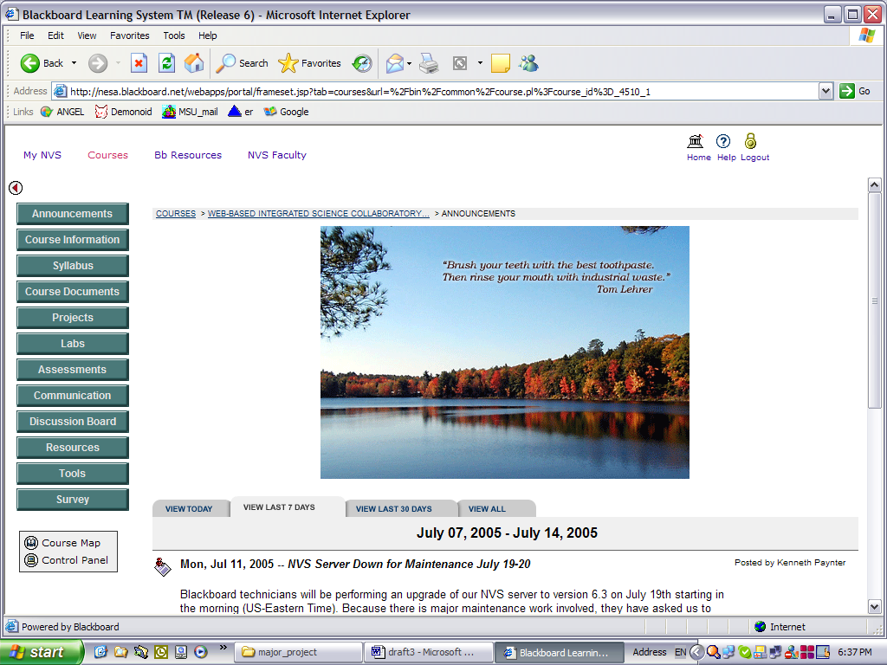

In this study I established realistic goals, prepared strategies to achieve them and then devised methods by which accomplishments would be measured and compared with the base line data at the beginning of the school year. The causal map for technology integration planning is shown below. The steps illustrated in this map (also called logical model for planning) provided a symbolic representation of a coherent long-term plan for the design and implementation of a classroom technology integration program.



**Participants’ Profile:**

### Sound decisions arise out of relevant knowledge of the students. The more the teacher knows about a student, the more likely the teacher is to arrive at a sound decision about the student or a wise plan of action for him (Thorndike 1969, p.8). Accordingly, it is important for the teacher to profile the students before taking decisions concerning the student. The senior profiles and the information listed below give the teacher an insight about the students’ abilities and their personality variables (without falling into the self-fulfilling prophecy trap).

* Class population: 25 students.
* The age of the students: ranges from 14-15 years.



The educational level:

All the students were ninth graders.

Most of the students had enabling science behaviors (prerequisite skills in English, 8th grade science and math).

Most of the students have English as their first language.

Most of the students had worked on a computer for more than 5 years to produce presentation, word documents, and in rare occasions web pages.

The ability level of the students:

The class was a mixture of medium-ability students and high-ability students who have better command of the subject matter and better skills of problem solving.

Nevertheless, most of these students needed to work harder on mathematically related problems. Therefore, there was always more time allotted to items requiring mathematical calculations.

Access and Inequity:

Most of the students had home internet access. Some of them had very restricted access due to large phone bills and/or competition between family members for phone line usage. I tried to come up with a contingency plan for those who had “constricted” home computer access. Students two periods per week in the computer lab where they were trained for the Web-Based Integrated Science Collaboratory (WISC) course. They were able to access two drop-in computer labs and their 40 machines during their flex time, after school (3:00-4:00), and during breaks.

**EVALUATION PROCEDURES**

An important element of any educational innovation should be an assessment of its impact and effectiveness on learning and teaching.

I was engaged in a research program comprised of three interdependent studies on student uses of Collaboratories. My strategy for assessing project results emerged from the Collaboratory pilot program to provide useful design information to all science teachers and administration.

**The First Study:** This study was an ongoing assessment of student background and attitudes toward science. Through surveys administered two times during the year, this study provided a detailed picture of each student's demographics and longitudinal data on attitudes toward science.

I used the following assessment tools before and after the implementation of the program:

* + Attitude Measurement to obtain measures of student’s attitudes toward the Chemistry Class: Students have provided anonymous responses.
  + Computer Attitude Questionnaire (CAQ) to provide information about student’s interests and use of computer technologies. I was able to obtain an interest score for each individual student by combining the results for the entire survey. I made sure that they understood the purpose of the measurement tool, and that there were no right or wrong answers that would influence their grades.

In this study, attitude improvements provided evidence for the proportion of students who were becoming more enthusiastic about learning science and working with Collaboratories for learning. Technology and science teachers can use the survey instrument and research design to study the impact of new pedagogy and technological infusion. The data could be of direct value to the administrators and curriculum coordinators.

**The second study: Student Interviews.** This study is a qualitative analysis of student responses to the interviews. In this study I compared their reactions and experience with the results from the surveys. Interviews provided insights as to why the students liked or disliked the tech-infused learning environment.

**Third Study: Integration & utilization of technology in the classroom and tech support**

Through Collaboratories,students were using a diverse suite of technology tools, involving different multi media software programs.

Teachers are usually the primary instructional agents in the classroom, and project-enhanced science learning brings new challenges to the instructional tasks involved in supporting student learning. Given the new computer and communications tools, and the distributed character of the learning environment, I was trying to determine through periodic reflection/feedback what my perspectives were on the changes brought about or initiated by these innovations and the nature of technology support needed through out the year to implement such a Collaboratory project.

**Results**

Data for this research were drawn from 26 students in two ninth grade classes that I am currently teaching. All students in both sections were required to complete the surveys as the intervention is considered a part of my planned instruction of the year.

The students completed a Computer Attitude Questionnaire (CAQ-Denton, TX: Texas Center for Educational Technology) to provide information about their motivation and use of computer technologies. This survey was selected because it measured more than just computer use. The survey also measured participation, preparedness for classes and attitude toward learning, which may be considered as motivation latent variables. The items used in this analysis related to students’ general motivation to learn and not computer use, thus, for the purposes of this paper I will refer to the measure as Student Motivation to Learn (SML).

They have also completed another 30 min Science Attitude Survey (SAS) that included 42 questions addressing attitude towards learning science specifically. These surveys have been administered twice a year before and after the intervention.

Toward the end of the study, interviews were conducted with 25% of the students, randomly selected, from both classes. The interviews focused on two aspects: (a) what the students have learned from the WISC; and (b) why they liked or disliked the “green journey”. Sample interview questions included “Which part did you like the most/least and why?”

The interview data were transcribed then coded and categorized according to their common themes and shared relationships. Extracted patterns from qualitative data were used to substantiate the results from the statistical analyses.

**Student Motivation to Learn**

After selecting the items from the CAQ that logically seemed related to student motivation to learn, data was analyzed using the t-test method to determine if there is a statistically significant difference between the mean scores.

Please refer to the appendix 2 to view the preliminary assumptions for this statistical analysis and the statistical calculations and the corresponding equations needed to examine the effect of technology on student motivation. Motivation was measured using a four-item scale (adapted from END CAQ Ver 5.22) with a 5-point response format ranging from "Strongly Disagree" to "Strongly Agree".

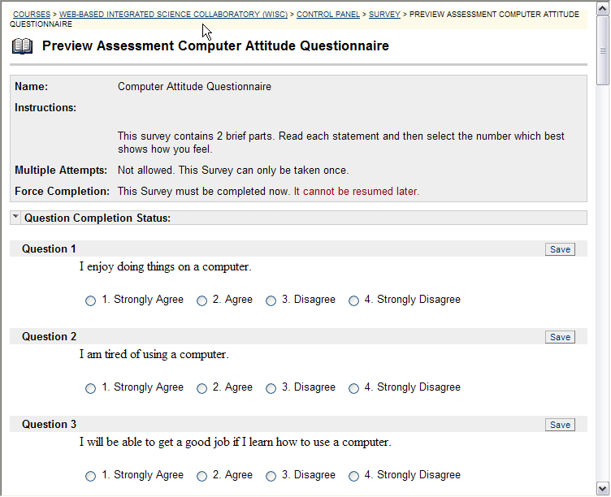

The questions in the survey which were used for the first analysis are:

1. I study by myself without anyone forcing me to study.
2. If I do not understand something, I will not stop thinking about it.
3. When I don’t understand a problem, I keep working until I find the answer.
4. I review my lessons every day.
5. I try to finish whatever I begin.
6. Sometimes, I change my way of studying.
7. I enjoy working on a difficult problem.
8. I think about many ways to solve a difficult problem.
9. I never forget to do my homework
10. I like to work out problems which I can use in my life every day.
11. If I do not understand my teacher, I ask him/her questions.
12. I listen to my teacher carefully.
13. If I fail, I try to find out why.
14. I study hard.
15. When I do a job, I do it well.

Those types of items are related to motivation. They are indicators for participation, preparedness for classes and attitude toward learning, which may be considered as motivation latent variables.

The purpose of this test is to determine if there is a statistically significant difference between the mean scores of the pre and post assessment tools. Because the t-test is a parametric statistic, it will be able to uncover slight differences in my small sample. The independent variable will be the use of a Tech-Infused Problem Based Learning module. The dependent (ordinal) variables are the students’ motivation. Table 1 shows the pre and post weighted averages for each student and the difference between their scores (D).

|  |  |  |  |  |  |
| --- | --- | --- | --- | --- | --- |
| **Students ID's** | **Survey Values** | **Pre** | **Post** | **D** | **D2** |
| Std ID 1 |  | 44.0 | 44.0 | 0.0 | 0 |
| Std ID 2 |  | 34.0 | 42.0 | 8.0 | 64 |
| Std ID 3 |  | 33.0 | 35.0 | 2.0 | 4 |
| Std ID 4 |  | 44.0 | 48.0 | 4.0 | 16 |
| Std ID 5 |  | 32.0 | 34.0 | 2.0 | 4 |
| Std ID 6 |  | 31.0 | 35.0 | 4.0 | 16 |
| Std ID 7 |  | 39.0 | 42.0 | 3.0 | 9 |
| Std ID 8 |  | 34.0 | 36.0 | 2.0 | 4 |
| Std ID 9 |  | 47.0 | 41.0 | -6.0 | 36 |
| Std ID 10 |  | 36.0 | 38.0 | 2.0 | 4 |
| Std ID 11 |  | 55.0 | 52.0 | -3.0 | 9 |
| Std ID 12 |  | 39.0 | 39.0 | 0.0 | 0 |
| Std ID 13 |  | 33.0 | 34.0 | 1.0 | 1 |
| Std ID 14 |  | 11.0 | 24.0 | 13.0 | 169 |
| Std ID 15 |  | 32.0 | 36.0 | 4.0 | 16 |
| Std ID 16 |  | 25.0 | 37.0 | 12.0 | 144 |
| Std ID 17 |  | 17.0 | 38.0 | 21.0 | 441 |
| Std ID 18 |  | 26.0 | 38.0 | 12.0 | 144 |
| Std ID 19 |  | 19.0 | 11.0 | -8.0 | 64 |
| Std ID 20 |  | 27.0 | 40 | 13.0 | 169 |
| Std ID 21 |  | 26.0 | 37.0 | 11.0 | 121 |
| Std ID 23 |  | 30.0 | 34.0 | 4.0 | 16 |
| Std ID 24 |  | 32.0 | 37 | 5.0 | 25 |
| Std ID 25 |  | 44.0 | 48.0 | 4.0 | 16 |
| Std ID 26 |  | 32.0 | 37 | 5.0 | 25 |

Table 1. Pre and Post Weighted Averages

According to t-test analysis, the increase in student motivation to learn after participating in the Collaboratory was statistically significant, t(25)=,3.55 p<.01; pretest mean =32.9 SD= 1.25; posttest mean =37.5 (see appendix 2 for all statistical calculations).

Table 1. Comparison of motivation levels in pre & post conditions

|  |  |  |  |
| --- | --- | --- | --- |
| **Conditions** | **Mean** | **(SD)** | **T** |
| **Pre** | 32.9 | 1.245512656 | 3.55120994* |
| **Post** | 37.5 |  |  |

* p < .01

**Science Attitude Survey**

Since the data is focused on comparisons, a second analysis was conducted using the results collected from the SAS (Appendix 1). The resulting graph in figure 1 clearly shows the difference between pre and post survey results. The scores of the numbered questions are the items weighted average for all twenty six students in both classes. The questions in the survey were divided into four constructs:

* high intrinsic motivation/determination to complete tasks (12, 13, 15, 16, 17, 20, 21, 32, 33, 34, 41)
* authentic/real/meaningful projects (1, 5, 8, 23, 24, 26, 27, 28, 29, 30, 35, 37, 39, 42)
* fun & enjoyable learning experiences (3, 7, 10, 25)
* open ended/ multi-faceted/ individual perspectives (2, 4, 9, 11, 18, 22, 36, 40)



Figure 1: Student Attitude Level Before & After the Intervention

Results from the surveys have shown that the intervention has played an important role in influencing the constructs mentioned above.

Motivated students tend to approach challenging tasks eagerly, persist in difficulty (Question # 12: I am not satisfied until I understand why something works the way it does; Question # 15: If I am stuck on a chemistry problem my first try, I usually try to figure out a different way that works), and take pride in their achievement (Stipek, 1993).

Students with positive attitudes were more likely to sustain their efforts (Question # 16: Nearly everyone is capable of understanding chemistry if they work at it ) and have the desire to be involved in the learning tasks (Question # 25: I enjoy solving chemistry problems; and the inverse effect of Question # 3: a significant problem in learning chemistry is being able to memorize all the information I need to know).

The scores show that the intervention may have also influenced students’ attainment, consistency, and quality of work (Question # 7: It is useful for me to do lots and lots of problems when learning chemistry; Question # 30: Reasoning skills used to understand chemistry can be helpful to me in everyday life).

Moreover, students with higher positive attitudes found those real life PBL experiences meaningful and authentic (Question # 5: I think about the chemistry I experience in everyday life; Question # 28: learning chemistry changes my ideas about how the world works).

Positive attitude in student responses was reflected as well their appreciation to individuality and multi-faceted problems. Average scores to questions 2, 9, 18, 36 and 40 were much higher after the intervention. Those items attend to open-ended tasks (Question # 2: There could be two different correct values to a chemistry problem if I use two different approaches) and check for individual perspectives (Question # 9: As chemists learn more, most chemistry ideas we use today are likely to be proven wrong; Question # 36: There are times I solve a chemistry problem more than one way to help my understanding)

**Interviews**

Most of the students interviewed said they enjoyed the projects and had fun working on creating the multimedia artifacts.

They have provided different reasons for their opinions, which included having fun, being able to solve interesting real-life problems, use computers, and work in teams. The table shown below lists the two most frequently mentioned reasons for enjoying the projects.

Table 2. *Two Most Frequently Cited Reasons for Liking the Tech-Infused PBL Project*

________________________________________________________________

I enjoyed it because Sample Students' Comments

________________________________________________________________

It is fun and real • It’s fun. It allowed us to visit an island and experiment with chemicals. I never knew how polluted the Nile water was. I learned a lot from this experience.

• Being able to create Blogs and Discussion Forums to talk about these issues with our peers was interesting and fun.

I enjoyed sharing the movies and other artifacts with other HS students and my parents.

• I liked designing an action plan to save our environment because it made me feel like a real life politician.

• The felluka trip (Egyptian sailing boat) was really cool.

It uses computers

• I really enjoyed producing my own documentary movie and getting feedback from my friends.

I also enjoyed learning about blogs and the way people are communicating over the net.

• The easy instructions helped me learn to create my water pollution webpages. Our tech-buddies in the class also helped.

• I enjoy working on the computers…and I was always looking forward to it.

• It’s cool that you get to collaborate with your team to raise awareness about pollution and market environmentally friendly practices.

________________________________________________________________

**Authentic Tasks & Enjoyment**: “It is fun and real”

It is significant that a number of students cited being able to work independently and like a scientist as the most important reasons they enjoyed the WISC. One student stated, “I liked how you got to investigate and hypothesize and experiment to come up with different solutions, like a real ecologist would. I also liked how you had to relate everything we have studied in the class with the results we have collected on the island.” Another said, “It helps you learn a lot of things because you learn to read through a lot of material on the web and then choose the most relevant and meaningful to support your stand, which is really important.”

Students’ interest and motivation in the projects were reflected in quotes such as:

“During breaks and in the afternoons, me and my friends, we’d talk a lot about our action plan that would clean up the oil spills and prevent such problems from happening in the future. Pretending to be a state governor or the president, encouraged all of us to think seriously about our planet.”

**Working With Technology**: “It uses computers”

Teachers also observed: “Kids are talking about their science case studies outside of the classroom. They are spending hours of work after school in the computer lab to finish their assignments.”

Although being challenged, students also felt a sense of satisfaction after working hard and being able to create their multimedia artifacts. “My best experience was when I figured out how I was able to change my poster storyboard into a digital movie. I was proud of myself, the story, music, and recommendations we have selected for our movie”

When asked what they have learned from this journey, students mentioned chemistry in our environment, technology as well as research and problem-solving skills.

Only a few students were not as enthusiastic and said they were frustrated because of the hurdles they have faced with computers (refer to appendix 4).

**Discussion of Results**

The results of the study showed that the students had significantly increased their positive attitude towards science (Figure 1) from pretest to posttest. Students’ attitudes toward Chemistry and their intrinsic motivation were higher after using the intervention. Such findings indicated that the tech-infused PBL had a positive impact on ninth graders. The interview data indicated that most of the students were enthusiastic about those projects. The few negative responses (as indicated above) were mostly from students who may not be comfortable with computers, might not function properly under stressful conditions (deadlines), or possess a low self-concept which affects immensely their intrinsic motivation.

Problem-based learning attempts to capitalize on students’ collaborative skills and product creation. The data from this study showed that many students enjoyed the virtual learning environment because they liked communicating with their peers from another class and share their work with a large audience (WWW). They also liked “working out problems which [they] can use in [their] life everyday”. Allowing students to solve authentic complex problems and keeping them challenged appeared to motivate them (Deci & Ryan, 1985; Hidi & Harackiewicz, 2000). At the same time, the creation of multimedia artifacts by students helped them realize that chemistry is not only about memorization, textbooks, formulas, or equations. The majority of the students stated in question 42 (weighted average 3.3), “When studying chemistry, I relate the important information to what I already know rather than just memorizing it the way it is presented.”

Results have also shown that the PBL project strongly affected students’ attitude. Students’ positive attitude towards learning was evident in their answers (ID Question 6: item weighted average was 1.7 and became 3.1 after the study). Almost all the students in both classes agreed that “nearly everyone is capable of understanding chemistry if they work at it” and believed that “when [they] do a job, [they] do it well” after experiencing the WISC learning environment.

Challenging and meaningful problems gave students choices, and promoted perceived autonomy and self-determination that can have a positive effect on students’ motivation (Deci & Ryan, 1985; Hidi & Harackiewicz, 2000).

Thus, multimedia projects, PBL, and the use of an online learning environment all affect the likelihood that students will be engaged and interested in learning science, at least as measured by students surveys.

To summarize, these constructs are essential determinants of science learning. Attitudinal and motivational variables are influential in explaining the variability in science achievement. Attitudes toward science are flexible and can be altered through changes in instructional approaches. More positive attitudes can be inculcated by integrating technology in Problem-Based learning projects. These variables can be modified in contrast to socio-demographic and cognitive variables such as gender, ethnicity, and social class of students and their cognitive abilities.

**Benefits & Limitations**

Before interpreting the results, it is primordial to be aware that the feedback was significantly higher for post surveys than for pre-surveys. Furthermore, all “undecided” or “Neither Agree or Disagree” responses were assigned a value of zero. “No opinion” was not regarded as a middle response and thus not given a numeric rating that might confound the statistics obtained by its misrepresentation.

The results shown in the graph and the t-test table suggest that students academic engagement, attitude and motivation were influenced by the implementation of the WISC.

As Table 1 shows, across each format, motivation was higher for most of the students after the intervention (supporting the hypothesis). Interestingly, the level of motivation with student ID 19 was lower after the intervention. Student ID 1 motivation was at the same level as before the intervention.

Frustrations in technology can sometimes turn off students. To more accurately interpret these associations between tech-infused PBL practices and student motivation, it is important to consider other factors that might affect both student engagement and attitude. I ought to examine in the future the following: subject-matter responsibilities, student ability level, and positive home experiences.

It is worth mentioning that the tech-infused PBL projects did not only impact student motivation but also their academic achievement. This finding was investigated by our high school science department when students in both research classes scored much higher than students in other classes taught in a traditional classroom environment. The difference in (final semester common assessment) averages was around 9%. The mean of the students involved in the PBL project was 83%. The exam papers were corrected by all teachers teaching the subject matter for inter-rater reliability.

I am unaware whether such a project improved their scores on Chemistry tests or a combination of various uncontrolled variables which might have affected their achievement. Therefore, future research needs to carefully examine the relationship between motivation, interest, and performance.

The study designs contained limitations that may have affected the results. First, the survey items differed between the two sessions – students were discouraged to select “no opinion” as an alternative. However, the differences in survey conditions may have affected participants’ responses. Second, participants expressed verbally their frustrations towards submitting the multimedia artifacts on time and overcoming the hurdles innate in the technology lab schedules. Third, in this research, the attempt to isolate the effects of the technology as a distinct independent variable was quite challenging. Was the enhanced motivation due to the use of software programs (to produce an artifact to an audience), online platform (for electronic communication, written expression, e-collaboration, information-gathering), or just the instructional design of a PBL project (working on a meaningful case relevant to their lives and to their direct environment)? Lastly, the time available for each participant to actually use the software programs was short, which left little time for experimentation and learning. This could help to explain their concerns and stressful moments. Such short experimental times are not uncommon in technology-based instructional research, but certainly can be criticized (Reeves, 1993).

There is also a need for more research regarding the measurement of affective and motivational variables. One limitation of research in this area is the measurement of complex constructs that are difficult to evaluate with high reliability and validity. Notwithstanding the limitation, the fact that the hypothesized relationship was statistically significant and was substantial in size supports this study and its findings.

Despite these limitations, this study has several strengths. First, this research responds to calls for more studies on engagement in tech-infused PBL, and in multimedia in particular. Second, it employs many features of Virtual Learning Environments as a supplement to traditional classrooms. This study provides a start toward the development of an online-PBL environment. Finally, study results have implications for online platform designers in the growing market for Virtual Schooling in education.

**Implications for research and practice**

In reviewing the literature about attitudes toward science over the past 20 years, Osborne, Simon, and Collins (2003) noticed that research indicated a deterioration in attitudes toward science from age 11 onwards. They have also remarked an apparent incongruity between students’ attitudes toward learning science in general and their attitudes toward science taught at school. Students consider science itself exciting and valuable but regard science lessons as monotonous (Ebenezer & Zoller, 1993). Osborne, et al. examined the factors that can affect attitudes such as gender, teachers, curricula, and culture; and highlighted the importance of the instructional design and its impact on students’ attitudes.

The purpose of this study was to examine the effect of technology on motivation and attitude towards learning science. The results of the study are consistent with results reported by other researchers mentioned in the literature review. The results have both practical and theoretical significance. They provide some ideas for educational interventions such as the use of technology applications by the students to plan, produce, demonstrate, and share their work with peers, teachers, and parents. If the use of computer technology is related to motivation, specific strategies can be designed and developed to involve students in science-related curricular and co-curricular activities.

Lack of student motivation in learning science specifically has been an issue of persistent concern to educators and school administrators. There is a need to provide more information and counseling to students about science subjects and their future use, which would spur further interest in science. Educators have an opportunity to change the negative attitudes and strengthen more positive attitudes toward science by promoting better teaching practices and by providing positive experiences in the traditional chemistry class.

When students can be found to be taking their school work seriously enough to be investing their energy in the creation of their multimedia artifacts, whether extrinsically motivated by grades or intrinsically motivated by sincere interest in accomplishment, this study has succeeded in advancing their engagement and enhancing their interest in learning.

Designing learning environments for engagement offers to make interactions with computers and science material enjoyable and rewarding to the students. Although it is not difficult to be in favor of a learning environment that students enjoy, some warn that “preference does not equal performance”: the environment that students prefer may not actually be the one most conducive to learning (Andre & Wickens, 1995). Elements such as multimedia artifacts, Blackboard, and sustainable problems may distract from a learning task -- or, they may maintain attention on the task. The outcome may depend on the way in which the elements relate to the learning material. This area requires further exploration in order to develop a more inclusive theory around motivational aspects of human-computer relationships.

**Personal Reflections**

 This project was especially conducive to enhanced student motivation because it stressed modes of learning beyond the traditional so often used in the academic setting. Using multimedia and a Virtual Learning Environment addressed various learning styles, which have been underemphasized in other chemistry classrooms.

Outcomes included:  
(1) Development of an interactive and virtual learning environment for student study of chemistry;   
(2) Enhanced student engagement using computer technology to appeal to multiple learning styles;   
(3) Created a successful collaborative project between the two science sections;   
(4) Provided a curriculum model that integrates sustainability, chemistry, and technology;   
(5) Demonstrated how students motivation and interest in chemistry was strengthened through the use of performance technology.

The following suggestions for facilitating the implementation of a PBL Tech-infused project:

**1. Allow sufficient time for students to explore their talents and develop expertise in using the software programs.**

**2. Encourage more networking among students in other classes** as they conduct their water pollution research projects. Suggest that they communicate online via e-mail/Blackboard forums or find other creative ways that permit students to share and learn from each other.

**3. Convey to students that the PBL project is a process.** They have the flexibility to try something, clarify, or modify it, and then try again.

**4. Discuss assessment procedures, data collection protocols, and MM instruments** that will provide documentation of the results of their field trip and research projects. Students often have an increased interest in assessment as they see its relevance to their own research questions (environmental need they are required to specify, document, solve and promote).

**5. Emphasize the importance of reporting their reflections, insights, and suggestions/improvements.** Suggest multiple methods such as keeping a journal, or using a morestructured method of recording ongoing observations. These documentations will be very useful to the teacher, student, and parents. The reflections will be part of students webfolios that can be used during Parent-Teacher conferences.

**6. Encourage students to share their findings** with their peers in other classes in the school through informal presentations.

**7. Be prepared to enjoy very meaningful and possibly new learning experience with your kids** as they research, define, experience their topics and create MM artifacts to explain their action plans expect to be challenged and rewarded in your new role as afacilitator.

Regarding my personal growth and learning experiences, here are some of the things I have learned throughout this journey:

The most significant resource which has emerged this semester is the role of the students in becoming the "teacher" when working with tech-infused projects. Often, the class has transformed into a learning community in which students role shifted from learning to teaching others. The students’ expertise in technology has been so helpful in engaging them in science projects. As important and obvious, is the collaboration between and among students. Differing knowledge-bases, specialized skills, and unique talents are now shared in a rich and resourceful environment. Because of this Problem-Based Learning project, students were able on many occasions to come together to think, plan, and implement innovative solutions to problems meaningful to their every day life experiences.

There is so much to look back on, not only with my research question (evaluating motivation in learning chemistry) but also with students artifacts and quality of their work.  Some of their assignments lacked depth and quality responses. I had to give more directed and structured instruction and allow for rewrites and improvements. In reference to this portion of my study, I know that it has changed the way that I look at using technology in science education.  I have learned a tremendous amount about how to use multiple software programs and virtual schooling (as a supplement to what I do in my traditional class settings) to effectively engage students in learning science ***without*** affecting the breadth and content of their projects.

This ARP has encouraged me to do more with technology. I will be using another PBL project with my kids next semester in my Physics unit. They will have to research, design, and build a Solar Car by the end of March. The Solar Cars will have to turn in different directions, be wireless (remote controlled), climb a certain slope (20 degrees), and move at a certain speed. The kids have to use a multimedia tool to present their design to the class and market the product (Webpage, PowerPoint, movie, or E-Poster). These cars will race each other during April (Earth Month) to promote and advertise the use of Clean Energy. I am also so excited about the fact that the kids themselves need to buy the materials (wood, wheels, axes, wires, etc…) for their cars. Gravity, friction, electricity, magnetism, waves and forces will all make sense to the students as they connect their schemata in their brains and move through their ZPD’s.

            I have thoroughly enjoyed this Action Research Project and the time I have invested with my classes broadening myself as a teacher and a learner.  Although it has been a rough and treacherous road, the rewards have been worth it.  As they say, nothing worth having comes easy.  This journey has not come easy and that is why I feel so satisfied and fulfilled at this point. **Appendices**

Appendix 1: Chemistry Attitude Survey (included in the Blackboard Course) 42 Likert Scale items

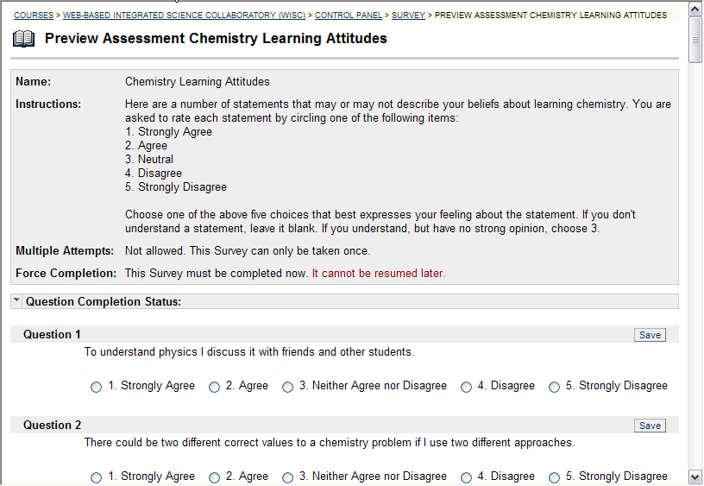Items highlighted in yellow are reverse coded since agreement would indicate low attitude.

|  |  |  |  |
| --- | --- | --- | --- |
| **Question ID's** | **Survey Items** | **Pre** | **Post** |
| Question ID 1 | To understand physics I discuss it with friends and other students.</P> | 1.7 | 2.6 |
| Question ID 2 | There could be two different correct values to a chemistry problem if I use two different approaches. | 1.4 | 2.6 |
| Question ID 3 | A significant problem in learning chemistry is being able to memorize all the information I need to know. | 1.4 | 2.3 |
| Question ID 4 | When I am solving a chemistry problem, I try to decide what would be a reasonable value for the answer | 2.0 | 3.3 |
| Question ID 5 | I think about the chemistry I experience in everyday life. | 2.0 | 2.3 |
| Question ID 6 | I find that reading the text in detail is a good way for met to learn chemistry. | 1.7 | 3.1 |
| Question ID 7 | It is useful for me to do lots and lots of problems when learning chemistry. | 1.4 | 2.7 |
| Question ID 8 | Knowledge in chemistry consists of many disconnected topics. | 1.3 | 2.3 |
| Question ID 9 | As chemists learn more, most chemistry ideas we use today are likely to be proven wrong. | 2.5 | 2.8 |
| Question ID 10 | When I solve a chemistry problem, I locate an equation that uses the variables given in the problem and plug in the values. | 2.3 | 2.6 |
| Question ID 11 | There is usually only one correct approach to solving a chemistry problem. | 2.0 | 2.7 |
| Question ID 12 | I am not satisfied until I understand why something works the way it does | 2.4 | 3.1 |
| Question ID 13 | I can not learn chemistry if the teacher does not explain things well in class | 1.3 | 1.7 |
| Question ID 14 | I do not expect chemistry equations to help my understanding of the ideas; they are just for doing calculations. | 2.1 | 2.6 |
| Question ID 15 | If I get stuck on a chemistry problem my first try, I usually try to figure out a different way that works. | 2.2 | 2.8 |
| Question ID 16 | Nearly everyone is capable of understanding chemistry if they work at it. | 2.4 | 3.1 |
| Question ID 17 | <P>I do not spend more than five minutes stuck on a chemistry problem before giving up or seeking help from someone else.</P> | 1.2 | 2.8 |
| Question ID 18 | There could be two different correct values to a chemistry problem if I use two different approaches. | 1.3 | 2.7 |
| Question ID 19 | Understanding chemistry basically means being able to recall something you've read or been shown | 1.4 | 2.4 |
| Question ID 20 | I do not spend more than five minutes stuck on a chemistry problem before giving up or seeking help from someone else. | 1.3 | 2.7 |
| Question ID 21 | If I don't remember a particular equation needed to solve a problem on an exam, there's nothing much I can do (legally!) to come up with it. | 1.5 | 2.3 |
| Question ID 23 | In doing a chemistry problem, if my calculation gives a result very different from what I'd expect, I'd trust the calculation rather than going back through the problem.</P> | 1.6 | 3.0 |
| Question ID 24 | In chemistry, it is important for me to make sense out of formulas before I can use them correctly.</P> | 2.9 | 3.24 |
| Question ID 25 | I enjoy solving chemistry problems. | 1.3 | 2.3 |
| Question ID 26 | In chemistry, mathematical formulas express meaningful relationships among measurable quantities. | 2.1 | 3 |
| Question ID 27 | It is important for the goverment to approve new scientific ideas before they can be widely accepted. | 1.9 | 2.9 |
| Question ID 28 | Learning chemistry changes my ideas about how the world works. | 2.5 | 3 |
| Question ID 29 | To learn chemistry, I only need to memorize solutions to sample problems. | 2.2 | 2.9 |
| Question ID 30 | Reasoning skills used to understand chemistry can be helpful to me in my everyday life. | 2.1 | 3 |
| Question ID 31 | We use this statement to discard the survey of people who are not reading the questions. Please select agree-option 4 (disagree) for this question to preserve your answers. | 0.0 | 0.0 |
| Question ID 32 | Spending a lot of time understanding where formulas come from is a waste of time. | 1.6 | 2.7 |
| Question ID 33 | I find carefully analyzing only a few problems in detail is a good way for me to learn chemistry. | 2.0 | 2.7 |
| Question ID 34 | I can usually figure out a way to solve chemistry problems | 1.7 | 2.7 |
| Question ID 35 | The subject of chemistry has little relation to what I experience in the real world. | 2.1 | 2.7 |
| Question ID 36 | There are times I solve a chemistry problem more than one way to help my understanding. | 1.7 | 2.7 |
| Question ID 37 | To understand chemistry, I sometimes think about my personal experiences and relate them to the topic being analyzed. | 2.4 | 2.6 |
| Question ID 38 | It is possible to explain physics ideas without mathematical formulas. | 1.4 | 2 |
| Question ID 39 | When I solve a chemistry problem, I explicitly think about which chemistry ideas apply to the problem. | 1.7 | 2.8 |
| Question ID 40 | It is possible for chemists to carefully perform the same experiment and get two very different results that are both correct. | 1.4 | 2.7 |
| Question ID 41 | If I get stuck on a chemistry problem, there is no chance I'll figure it out on my own. | 2.1 | 2.9 |
| Question ID 42 | When studying chemistry, I relate the important information to what I already know rather than just memorizing it the way it is presented. | 1.9 | 3.3 |

Appendix 2: Statistical Analysis

**Preliminary Assumptions:**

Because the t-test is a parametric statistic, there are few preliminary assumptions that I must undertake before I implement the statistical procedure:

* The two groups should have equal variances on the dependent variable. It is the case since I will be using the same group at two different times.
* The two groups should have an equal number of subjects (this is also true because of the same reason mentioned above).
* Groups should be equivalent on all other variables except the dependent variables (same as above).

***Step One:*** *Stating the non-directional null hypothesis (Carroll, 2002).*

There is no difference in student motivation before and after the use of WISC.

***Step Two****: Probability Level*

The probability level I have adopted is 0.05. With this probability level I will accept five times in 100 that my results were due to chance.

***Step Three:*** *Looking at factors contributing to Power*

I will be using parametric statistics, directional hypothesis, and a liberal probability level. On the other hand, my sample is quite small and the attributes of the evaluation instruments might not have high reliability and validity.

***Step Four:*** *Setting up the Data for Data Entry into a Database (Microsoft Excel worksheet attached to this document) & Executing the t-test Statistical Procedure to Obtain a Calculated t Value (*Lowry, 2005)

**t** = **MD**  / **est.inewsigMD** = 3.55120994

***Step Five:*** *comparing the calculated t value to the critical t value in the t distribution table (my degrees of freedom will be pairs-1=25)*

**

Table 2. T Distribution Table

For the sample of N values of **Di**, where each instance of **Di** is equal to XAi—XBi (table 3), I have calculated the mean of the sample as:   
**MD** = sum**Di**i / N= 4.423076923

*The sum of squared deviates is:*

**SSD** =isum**D2i** — (isum**Di**)2/N= 1008.346154

The standard deviation of the sampling distribution of **MD** was estimated as: est.newsig**MD** = **sqrt** [{**s**2}/iNi] = 1.245512656  
*Critical t value is: 2.06 < 3.55*  
  
The calculated **t** exceeds the critical value for the .01 level, hence can be regarded as significant beyond the .01 level. The conclusion is that the likelihood of the experimental result having come about through mere chance coincidence is a bit less that 1%. So at the level of about 99%, that data collected reflect something more than mere random variability.

***Step Six:*** *Accept the Null Hypothesis.*

Appendix 3: **UCHRIS Approval & Parental Consent**

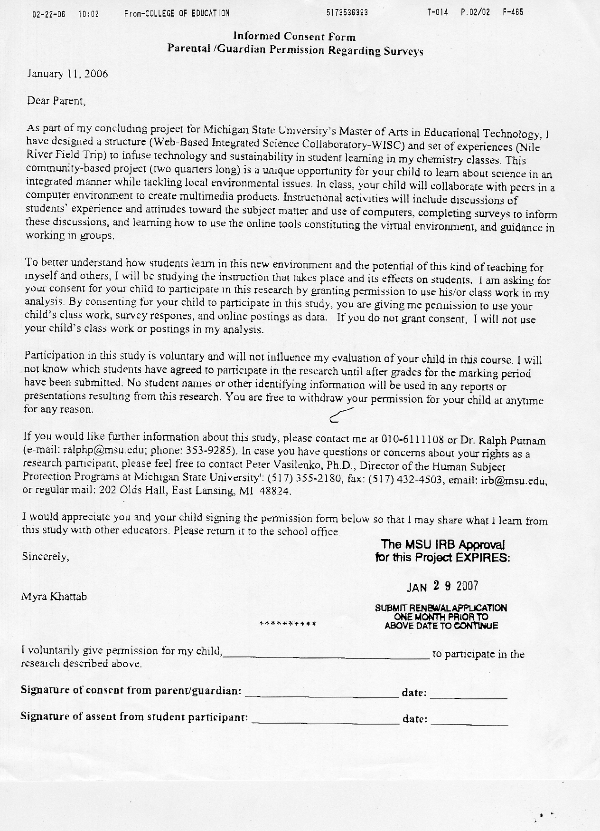

Appendix 4: **Challenges of Tech-Integration**

1. *“Integrating technology requires special expertise, training and equipment.”* I personally find it to be doubly challenging because I have to tackle both learning how to use technology and learning how to become an action researcher.
2. *Time: it takes a lot of time to learn, teach, improve, monitor, follow-up and assess!*
3. We have faced so many problems with the HS Server. It crashed twice and was inaccessible during back-up periods.
4. students took quite a while to learn how to log in to their computers in the lab, connect to the server, create folders to save their work in, access the Blackboard website, enter the BB class, navigate through its various components, upload assignment with the proper extensions, and become responsible digital citizens.
5. At school we have Mac computers and all students have PC’s at home. Teaching students how to work with both was an enriching experience.
6. The computers in the lab have crashed many times when students had to work simultaneously with Photoshop, Dreamweaver, Word, and the internet.
7. Recording narration for their movies in the computer lab posed some nuisance for all the students and complicated the audio recording process.
8. When ALL the students try to access my drop in box in the server at the same time, things get messy. They have to copy and paste their assignments/folders one at a time.
9. Students had problems with Mac Administrator and couldn’t log in to the machines.
10. The LCD projector’s bulb got burned out. The computer labs (4 with 20 computers each in the HS) were fully booked. The printer cartridges connected to this lab needed to be replaced. Photoshop is not installed in the “Writing Computer Lab” etc…

Appendix 5: **Summary of the Benefits of using Blackboard**

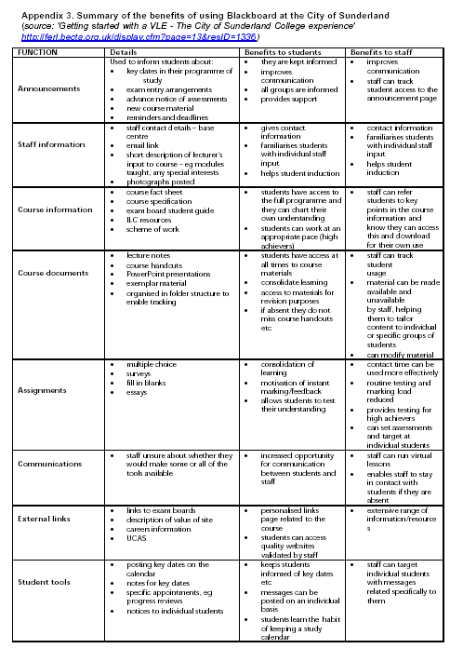

**The educational advantages which may arise when supplementing the classroom with VLE course components are:**

1. Support of web-based education tools, including access to learning resources (learning resources might be self-developed or professionally authored and purchased, and can be imported and made available for use by students). The organization and easy access to materials enable student-centred learning approaches. Students can utilize materials and resources that best fit their plans for solving their problems (Problem-Based Learning cases).
2. Communications between the learner, the teacher and other learning support specialists to provide direct support and feedback for learners, as well as class members communications that build a sense of group identity and a community of interest (Discussion Boards, Virtual Classroom and emails). Enhancing student-to-student and teacher-to-teacher communication provide more opportunities for collaborative work regardless of the time and space of the participants. Students experience a sense of equality by having equal chances to participate and share their perspectives with the rest of the class.
3. Providing opportunities for exploration, 24/7 accessibility to course materials, and missed work.
4. Controlled access to the curriculum map which includes assessment procedures and standards. Ease of monitoring student activity and achievement against these elements (multiple assessment types and surveys). Students will be able to get immediate feedback for these on-line administered tests and to create an electronic folder that documents all their work.

In addition to these features, Blackboard can also provide the following elements:

* + a level of security built into the system (password protection)
  + two views of the on-line course, one for the tutor and one for the student
  + a knowledge of HTML is not a requirement in order to use or contribute content to the system
  + continual access to materials

Appendix 6: **Informed Consent Form**

**Parental /Guardian Permission Regarding Data Analysis**

December 10, 2005

Dear Parent,

As part of my concluding project for Michigan State University’s Master of Arts in Educational Technology, I have designed a structure (Web-Based Integrated Science Collaboratory-WISC) and set of experiences (Nile River Field Trip) to infuse technology and sustainability in student learning in my chemistry classes. This community-based project (two quarters long) is a unique opportunity for your child to learn about science in an integrated manner while tackling local environmental issues. In class, your child will collaborate with peers in a computer environment to create multimedia products. Instructional activities will include discussions of students’ experience and attitudes toward the subject matter and use of computers, learning how to use the online tools constituting the virtual environment, and guidance in working in groups.

To better understand how students learn in this new environment and the potential of this kind of teaching for myself and others, I will be studying the instruction that takes place and its effects on students. I am asking for your consent for your child to participate in this research by granting permission to use his/or class work in my analysis. By consenting for your child to participate in this study, you are giving me permission to use your child’s class work and online postings as data. If you do not grant consent, I will not use your child’s class work and postings in my analysis.

Participation in this study is voluntary and will not influence my evaluation of your child in this course. No student names or other identifying information will be used in any reports or presentations resulting from this research. You are free to withdraw your permission for your child at anytime for any reason. To protect your child’s confidentiality, I will not use student names or other identifying information in any reports of this research.

If you would like further information about this study, please contact me at 010-6111108 or Dr. Ralph Putnam (e-mail: ralphp@msu.edu; phone: 353-9285). If you have questions or concerns regarding your rights as a study participant, or are dissatisfied at any time with any aspect of this study, you may contact—anonymously, if you wish—Peter Vasilenko, Ph.D., Chair of the University Committee on Research Involving Human Subjects (UCRIHS) by phone (517) 355-2180, fax: (517) 432-4503, e-mail: ucrihs@msu.edu or regular e-mail: 202 Olds Hall, East Lansing, MI 48824.

I have read and understand the above, I voluntarily give permission for my child,___________________________________ to take the surveys.

_______________________________________________________________________

Parent or Guardian Signature Date

**References:**

Directions in knowledge networking: Advances and opportunities.from <http://www.dl.ulis.ac.jp/ISDL97/proceedings/gmo/gmo.html>

<http://www.dl.ulis.ac.jp/ISDL97/proceedings/gmo/gmo.html>

Multimedia. *Science, 301*, 1474-1476.

Uwired: University of washington.from <http://www.washington.edu/uwired/>

<http://www.washington.edu/uwired/>

National collaboratories: Applying information technology for scientific research. (1993). from <http://www.nap.edu/catalog/2109.html>

<http://www.nap.edu/catalog/2109.html>

National collaboratories applying information technology for scientific research. (1993). from <http://www.netlibrary.com/urlapi.asp?action=summary&v=1&bookid=14104>

Materials specified: Bibliographic record display <http://www.netlibrary.com/urlapi.asp?action=summary&v=1&bookid=14104> Note: An electronic book accessiblethrough the World Wide Web; click for information

Improving research capabilities in chemical and biomedical sciences: Proceedings of a multi-site electronic workshop. (1999). *The Compass series; Variation: Compass series (Washington, D.C.)*, from <http://www.nap.edu/catalog/9465.html>

<http://www.nap.edu/catalog/9465.html>

Improving research capabilities in chemical and biomedical sciences proceedings of a multi-site electronic workshop. (1999). *The Compass series; Variation: Compass series (Washington, D.C.)*, from <http://www.netLibrary.com/urlapi.asp?action=summary&v=1&bookid=8749>

Materials specified: Bibliographic record display <http://www.netLibrary.com/urlapi.asp?action=summary&v=1&bookid=8749> Note: An electronic book accessible throughthe World Wide Web; click for information

Albion, P. R. (2000). Problem-based learning as a multimedia design framework in teacher education. *Journal of Technology and Teacher Education, 8*(4), 315-326.

Albion, P. R. (2003). Pbl + imm = pbl2: Problem based learning and interactive multimedia development. *Journal of Technology and Teacher Education, 11*(2), 243-257.

Bainbridge, W. S. (1999). International network for integrated social science. *Social Science Computer Review, 17*(4), 405-420.

Berliner, B. A. (2004). Reaching unmotivated students. *The Education Digest, 69*(5), 46-47.

Burdick, T. A. (1998). Pleasure in information seeking: Reducing information aliteracy. *Emergency Librarian, 25*, 13-17.

Butler, S. M. (2003). Designing a technology-based science lesson: Student teachers grapple with an authentic problem of practice. *Journal of Technology and Teacher Education, 11*(4), 463-481.

Dhillon, M. S. (2003). An event-based middleware architecture for interactive computational collaboratories (pp. vii, 34 leaves).

Fitzgerald, G. E. (1996). Technology-assisted instruction for students with learning disabilities. *Journal of Computing in Childhood Education, 7*(3-4), 123-125.

Flynn, A. E. (2001). The influence of discussion groups in a case-based learning environment. *Educational Technology Research and Development, 49*(3), 71-86.

Hancock, D. R. (2002). Influencing university students' achievement and motivation in a technology course. *The Journal of Educational Research*, 365-372.

Karet, G. (1999). Getting ahead in a 'man's world'. Women scientists and engineers. *R&D Magazine, 41*(10), 10SE-11SE.

Knapp, N. F., & Winsor, A. P. (1998). A reading apprenticeship for delayed primary readers. *Reading Research and Instruction, 38*(1), 13-29.

Lunsford, K. J. (2001). Collaboratories: Working together on the web. *Journal of Adolescent & Adult Literacy, 45*(1), 52-58.

McGrath, D. (2003). Artifacts and understanding. *Learning and Leading with Technology, 30*(5), 22-24, 26-27.

McInerney, D. M., & McInerney, V. (1998). The goals of schooling in culturally diverse classrooms. *Clearing House, 71*(6), 363-366.

Merriweather, M. (1999). The effect of instruction with graphing calculators on how general mathematics students naturalistically solve algebraic problems. *The Journal of Computers in Mathematics and Science Teaching, 18*(1), 7-22.

Miller, E., & Westmoreland, G. (1998). Student response to selective grading in college economics courses. *Journal of Economic Education, 29*(3), 195-201.

Mingus, T. T. Y. (1999). What constitutes a nurturing environment for the growth of mathematically gifted students? *School Science and Mathematics, 99*(6), 286-293.

Murray, J. Contemporary literacy: Essential skills for the 21st century. *Multimedia Schools, 10*(2), 14-18.

Nadolski, R. J. A model for optimizing step size of learning tasks in competency-based multimedia practicals. *Educational Technology Research and Development, 49*(3), 87-103.

O'Looney, J. Applying learning principles to development of multimedia for addressing bias in street-level public decision-making. *Journal of Educational Multimedia and Hypermedia, 12*(2), 163-183.

Parker, V. Effects of a science intervention program on middle-grade student achievement and attitudes. *School Science and Mathematics, 100*(5), 236-242.

Reis, S. M., & et al. (1998). A response: Equal does not mean identical. *Educational Leadership, 56*(3), 74-77.

Riedel, J. The design of computerized practice fields for problem solving and contextualized transfer. *Journal of Educational Multimedia and Hypermedia, 12*(4), 377-398.

Rinne, C. H. (1998). Motivating students is a percentage game. *Phi Delta Kappan, 79*(8), 620-624,626,628.

Ross-Flanigan, N. The virtues (and vices) of virtual colleagues. *MIT's Technology Review, 101*, 52-59.

Saye, J. W. Scaffolding critical reasoning about history and social issues in multimedia-supported learning environments. *Educational Technology Research and Development, 50*(3), 77-96.

Sheldon, K. M., & Biddle, B. J. (1998). Standards, accountability, and school reform: Perils and pitfalls. *Teachers College Record, 100*(1), 164-180.

Sonnenwald, D. H. (2003). Scientific collaboratories in higher education: Exploring learning style preferences and perceptions of technology. *British Journal of Educational Technology, 34*(4), 419-431.

Stipek, D., Salmon, J. M., Givvin, K. B., Kazemi, E., Saxe, G., & MacGyvers, V. L. (1998). The value (and convergence) of practices suggested by motivation research and promoted by mathematics education reformers. *Journal for Research in Mathematics Education, 29*(4), 465-488.

Wallis, C. (1998). Their eight secrets of success. *Time Magazine, 152*(16), 80-86.

Zumbach, J. Using multimedia to enhance problem-based learning in elementary school. *Information Technology in Childhood Education*, 25-37.

1. The **Blackboard Learning System**™ is a Web-based server software platform that offers industry-leading course management, an open architecture for customization and interoperability, and a scalable design that allows for integration with student information systems and authentication protocols.
2. **Collaboratory** (References) is a learning environment where students come together in a synchronous and asynchronous manner to learn from one another and collaborate in an online virtual environment. Blackboard is used as a platform for creating such an environment. Providing students with these communication technologies allows them to work together beyond the classroom walls.